**VIBRATION MONITORING**

**DEPARTMENT OF MECHANICAL AND INDUSTRIAL ENGINEERING**

by

**NATHAN ROBINSON**

**ME405, MECHANICAL LAB-III**



***written with passion***



**Table of Contents**

Abstract 3

Introduction 4

Theory 5-6

Experimental Methodology 7-10

Numerical Analysis (calculations) 11-12

Discussion 13-21

Conclusion 22

References 23

Appendix 24

**Table of Figures**

Fig 1; Types of vibrations. 5

Fig 2; Dynamic shaker table. 7

Fig 3; Vibration monitor. 8

Fig 4; Isometric view of simple shaker table model. 9

Fig 5; Top view of simple shaker table model. 9

Fig 6; Front view of shaker table. 10

Fig 7; Freq. vs Disp. at (3.0 in) chart. 13

Fig 8; Freq. vs Vel. at (3.0 in) chart. 14

Fig 9; Freq. vs Acc. at (3.0 in) chart. 14

Fig 10; Freq. vs Disp. Ratio at (3.0 in). 15

Fig 11; Freq. vs Vel. Ratio at (3.0 in). 15

Fig 12; Freq. vs Acc. Ratio at (3.0 in). 16

Fig 13; Freq. Ratio vs Transmissibility Rate at (3.0 in) chart. 16

Fig 14; Freq. vs Disp. at (3.5 in) chart. 17

Fig 15; Freq. vs Vel. at (3.5 in) chart. 18

Fig 16; Freq. vs Acc. at (3.5 in) chart. 18

Fig 17; Freq. vs Disp. at (4.0 in) chart. 19

Fig 18; Freq. vs Vel. at (4.0 in) chart. 20

Table 1; Excel Data table for 3.0 in test including ratios. 21

**Abstract**

The vibration table produced forced vibration on the cantilever beam from the center of the table toward the end mass location. Thanks to the sweep generator a frequency image can be displayed of the vibration wave regarding position displacement, velocity and acceleration.

The ratios obtained from the data given by the vibration monitor as for the displacement position displacement, velocity and acceleration resulted to be a max of 50.53, 48 and 28.5 respectively, all at a frequency of 36.1 which is just below the resonant frequency of 37. And the resonant frequencies from the 3.0, 3.5 and 4.0 tests were 37, 34.94 and 33.05 respectively.

**Introduction**

**Condition Monitoring**

Condition monitoring is the process of monitoring a parameter of condition in machinery, to then identify a significant change which is indicative of a developing fault.

The importance of condition monitoring is to prevent machine failure, and to predict the required future maintenance a machine will need. The execution of regular condition monitoring on all the parts of a machine can lead to avoiding high repair costs caused by potential machine breakdown. To measure a machines response a device is used to convert the machines vibration into an electrical signal that can be recorded and analyzed.

Although condition monitoring can give the ability to understand the condition of the machine is does not improve the reliability. Improving reliability involves taking a proactive approach and investigating the root causes of why the machine fails. These root causes can be anything from poor installation and operational practices to cleaning, adjusting movable parts and even replenishing lubrication oil if necessary.

**Vibration Monitoring**

Vibration analysis is widely used to monitor the frequencies being generated by moving machinery, using the machines vibration as a diagnostic tool. One commonly employed technique to analyze the vibration frequency is to examine the individual frequencies present in the signal. These frequencies correspond to certain mechanical components or certain malfunctions. By examining these frequencies and their harmonics, the location and type of problem can be identified, and sometimes the root cause as well.

**Theory**

**Moment of inertia**

The moment of inertia of an area is the measure of a beam’s ability to resist bending. Given equal loads a beam with a small moment of inertia will bend more than a beam with a large moment of inertia.

**Vibrations**

Vibrations can be seen as oscillatory motions about an equilibrium point. This motion can either natural or forced depending on whether the vibration was caused by a disturbing force that is applied once and then removed (natural) or if a force of impulse is applied repeatedly to a system (forced).

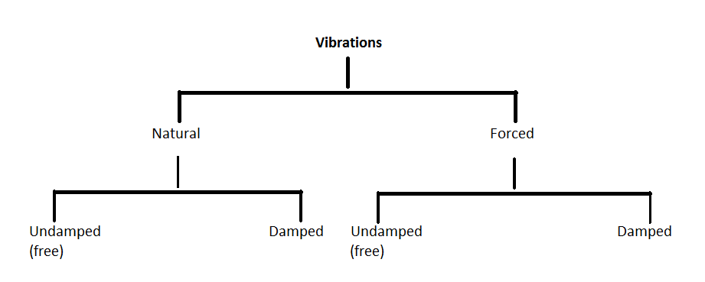

Fig 1; Types of vibrations.

In a vibrating system, the behavior of a linear component can be described by a linear equation. The linear equation F = kx describes a linear spring; however, the quadratic equation F = Cv2 describes a nonlinear dashpot. Similarly, F = ma and F = Cv are linear inertial and viscous forces, respectively.

An important concept used in calculating the behavior of a vibrating system is the static deflection δst. This is the deflection of a mechanical system due to gravitational force alone. The equation for a system at rest is mg = k δst.

**Experimental Methodology**

A dynamic shaker table is used to produce a vibrating motion onto the cantilever beams clamped symmetrically onto the apparatus. Also symmetrically onto both beams, masses are attached at a predetermined distance. Accelerometers are attached to the masses and the middle driving shaft.

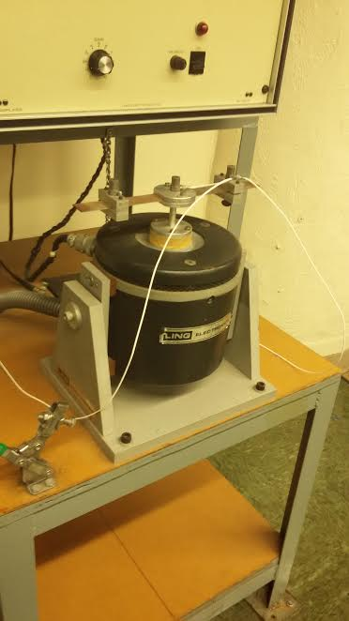

Fig 2; Dynamic shaker table.

Before activating the vibration motion, a balancing process needed to be followed in order to calibrate the accelerometers with the vibration monitor as well as the sweep generator.

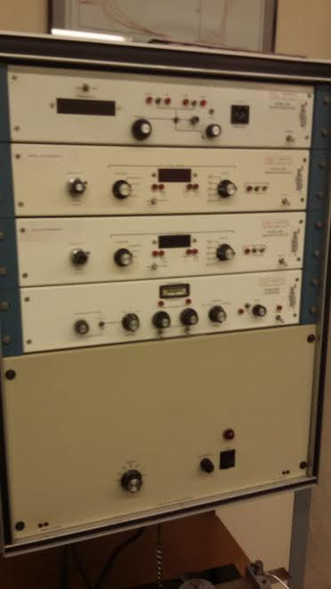

Fig 3; Vibration monitor.

When calibrated the accelerometers recorded of value of zero displacement velocity and acceleration when no vibration was being produced.

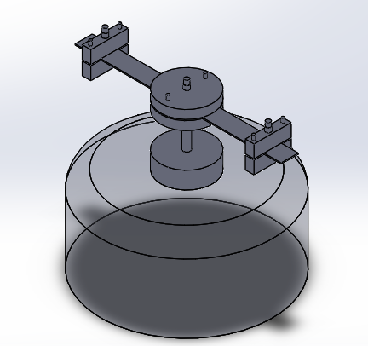

Fig 4; Isometric view of simple shaker table model.

The displacement, velocity and acceleration were recorded with the masses placed symmetrically from the center shaft at distances three different distances of 3, 3.5 and 4 inches.

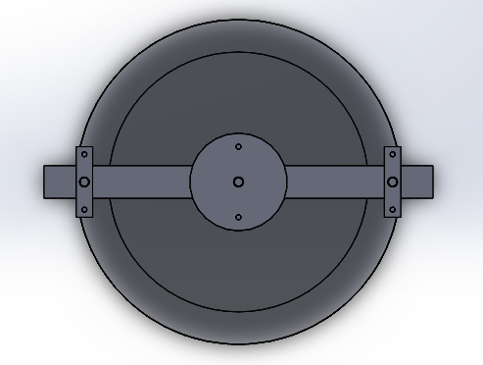

Fig 5; Top view of simple shaker table model.

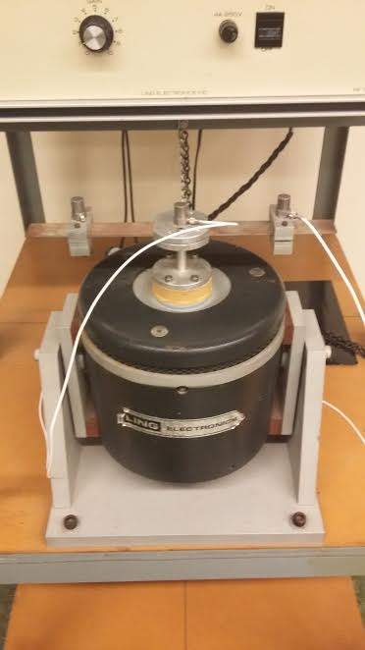

Fig 6; Front view of shaker table.

By using the sweep generator the frequency was set to a wide range of frequencies where displacement, velocity and acceleration were recorded. This process was repeated for the three different mass positions.

**Numerical Analysis**

**From data: w = 37 Hz; L = 3.0 in**

**Moment of Inertia**

I = 1/12 * b * h3 🡪 I = 1/12 * 1 * 0.0625in3 = 2.03X10-5in4

**Spring Constant**

Kc = 3EI/L3 🡪 Kc = 3(30X106psi)(2.03X10-5in4)/(3.0in)3 = 67.667 lbf/in

Kc = 67.667 lbf/in (32.2 lbm*ft/s2)(12 in/ft) = 26,146.53 lbm/s

m = 0.159 lbm

**Frequency**

wn = 🡪 Wn = 405.516 rad/s

f = wn/2π 🡪 f = 64.54 cycles/s

**Frequency Ratio**

β = w/wn = 37/64.54 = 0.573

P = (0.159 lbm)(32.2 ft/s2) = 5.1198 lbf

ẏmax = P/kc = 5.1198 lbt/ 67.667 lbf/in = 0.756 in

**Displacement Ratio**

Theoreritcal dispratio = 0.0867/0.0756 = 1.1468

dispratiomax = 86.7/5 = 17.34

dispratiomin = 20.6/19.2 = 1.0729

**Velocity Ratio**

Vrmax = 9.9/0.6 = 16.5

Vrmin = 0.3/0.4 = 0.75

**Acceleration Ratio**

Armax = 6/0.4 = 15

Armin = 0/0.1 = 0

**Transmissibility**

T = FT/Fo =

r = β = 0.573

at Ϛ = 0.5

T = 1.152/0.8829 = 1.3

**Discussion**

**Test 1**

The frequency change over the first test at the 3 in mass distance shows a max displacement ratio of 17.34 at a frequency of 37 Hz. Interestingly when plotting the frequency on the x-axis vs displacement on the y-axis the graph displays as a double-hump wave. And when the mass displacement is at its highest at 86.7 mils, the center displacement is at its low end at 5 mils. Thus from the experimental results the resonant frequency for the 3 in test is 37 Hz.

Fig 7; Freq. vs Disp. at (3.0 in) chart.

Fig 8; Freq. vs Vel. at (3.0 in) chart.

Fig 9; Freq. vs Acc. at (3.0 in) chart.

Fig 10; Freq. vs Disp. Ratio at (3.0 in).

Fig 11; Freq. vs Vel. Ratio at (3.0 in).

Fig 12; Freq. vs Acc. Ratio at (3.0 in).

Fig 13; Freq. Ratio vs Transmissibility Rate at (3.0 in) chart.

**Test 2**

The second test’s 3.5 in experimental results displayed on a freq. vs disp. curve prove to have a resonant frequency 34.94 Hz. seeing as this is where the highest displacement at 13.9 mils is seen on the curve. The max displacement is much lower than the first test’s at 86.7 mils due to the .5 in increase to the end mass location.

Fig 14; Freq. vs Disp. at (3.5 in) chart.

Fig 15; Freq. vs Vel. at (3.5 in) chart.

Fig 16; Freq. vs Acc. at (3.5 in) chart.

**Test 3**

The third test shows to have a resonant frequency of 33.05 Hz with a max displacement of 53.1 mils.

Fig 17; Freq. vs Disp. at (4.0 in) chart.

Fig 18; Freq. vs Vel. at (4.0 in) chart.

Fig 19; Freq. vs Acc. at (4.0 in) chart.

Table 1; Excel Data table for 3.0 in test including ratios.

|  |  |  |  |  |  |  |  |  |  |
| --- | --- | --- | --- | --- | --- | --- | --- | --- | --- |
| 3in | Center |  |  | Mass |  |  | Ratio |  |  |
| Frquency | Disp1 | Vel1 | Acc1 | Disp2 | Vel2 | Acc2 | Disp | Vel | Acc |
| 5.26 | 19.2 | 0.4 | 0.1 | 20.6 | 0.3 | 0 | 1.072917 | 0.75 | 0 |
| 9.98 | 19.1 | 0.7 | 0.1 | 20.9 | 0.7 | 0.1 | 1.094241 | 1 | 1 |
| 15.08 | 19.3 | 0.9 | 0.2 | 24 | 1.1 | 0.3 | 1.243523 | 1.222222 | 1.5 |
| 20 | 19.6 | 1.2 | 0.4 | 29.7 | 1.8 | 0.6 | 1.515306 | 1.5 | 1.5 |
| 25.03 | 19.5 | 1.5 | 0.6 | 41.8 | 3.2 | 1.3 | 2.14359 | 2.133333 | 2.166667 |
| 29.94 | 18.4 | 1.8 | 0.9 | 82.8 | 7.9 | 3.8 | 4.5 | 4.388889 | 4.222222 |
| 32.01 | 7.9 | 0.8 | 0.4 | 20.3 | 2 | 1.1 | 2.56962 | 2.5 | 2.75 |
| 33 | 7.4 | 0.8 | 0.4 | 35.2 | 3.6 | 1.9 | 4.756757 | 4.5 | 4.75 |
| 33.98 | 6.8 | 0.7 | 0.4 | 58 | 6.1 | 3.4 | 8.529412 | 8.714286 | 8.5 |
| 35.07 | 4.3 | 0.5 | 0.3 | 80.8 | 8.7 | 5.3 | 18.7907 | 17.4 | 17.66667 |
| 36.01 | 1.7 | 0.2 | 0.2 | 85.9 | 9.6 | 5.7 | 50.52941 | 48 | 28.5 |
| 37 | 5 | 0.6 | 0.4 | 86.7 | 9.9 | 6 | 17.34 | 16.5 | 15 |
| 38.04 | 5.5 | 0.7 | 0.4 | 38.2 | 4.6 | 2.9 | 6.945455 | 6.571429 | 7.25 |
| 40.07 | 5.1 | 0.7 | 0.4 | 18.8 | 2.4 | 1.5 | 3.686275 | 3.428571 | 3.75 |
| 45.08 | 4 | 0.6 | 0.4 | 6.5 | 0.9 | 0.7 | 1.625 | 1.5 | 1.75 |
| 50.02 | 3.4 | 0.5 | 0.4 | 3.3 | 0.5 | 0.4 | 0.970588 | 1 | 1 |
| 54.97 | 2.9 | 0.5 | 0.4 | 2.3 | 0.3 | 0.3 | 0.793103 | 0.6 | 0.75 |
| 60.01 | 2.4 | 0.4 | 0.4 | 1.4 | 0.2 | 0.2 | 0.583333 | 0.5 | 0.5 |
| 64.99 | 2.1 | 0.4 | 0.4 | 1.2 | 0.1 | 0.1 | 0.571429 | 0.25 | 0.25 |
| 69.97 | 1.8 | 0.4 | 0.4 | 1.2 | 0.1 | 0.1 | 0.666667 | 0.25 | 0.25 |
| 74.98 | 1.9 | 0.3 | 0.4 | 1.2 | 0.1 | 0.1 | 0.631579 | 0.333333 | 0.25 |

**Conclusion**

All the executed tests helped display the frequency image of the vibration crossing the cantilever beam, from the shaker table to the location of the end mass.

The ratios obtained from the data given by the vibration monitor as for the displacement position displacement, velocity and acceleration resulted to be a max of 50.53, 48 and 28.5 respectively, all at a frequency of 36.1 which is just below the resonant frequency of 37. Proving that the vibration frequency data generated can predict the resonant frequency by adjusting the sweep generator with lower intervals when approaching a near resonant frequency.

And the resonant frequencies from the 3.0, 3.5 and 4.0 tests were 37, 34.94 and 33.05 respectively. Experimentally displaying that the further the end mass is located, thus the lower the resonant frequency will be although this is not true for the max displacement being 86.7, 13.9 and 53.1 mils respectively, this due to the harmonic motion that the cantilever beam is undergoing.

**References**

"Condition monitoring." Wikipedia. Wikimedia Foundation, 14 Mar. 2017. Web. 26 Apr. 2017.

KCFTechnologiesInc. "Vibration Monitoring System Vibration Fundamentals Accelerometer Wireless Sensor Node." YouTube. YouTube, 02 June 2014. Web. 26 Apr. 2017.

RMS - Reliability Maintenance Solutions Ltd. "The Reason for Condition Monitoring." YouTube. YouTube, 26 Mar. 2015. Web. 26 Apr. 2017.

ME 406 Laboratory Manual Harnoy. New Jersey Institute of Technology.

**Appendix**

|  |  |  |  |  |  |  |  |  |  |
| --- | --- | --- | --- | --- | --- | --- | --- | --- | --- |
| 3in | Center |  |  | Mass |  |  | Ratio |  |  |
| Frquency | Disp1 | Vel1 | Acc1 | Disp2 | Vel2 | Acc2 | Disp | Vel | Acc |
| 5.26 | 19.2 | 0.4 | 0.1 | 20.6 | 0.3 | 0 | 1.072917 | 0.75 | 0 |
| 9.98 | 19.1 | 0.7 | 0.1 | 20.9 | 0.7 | 0.1 | 1.094241 | 1 | 1 |
| 15.08 | 19.3 | 0.9 | 0.2 | 24 | 1.1 | 0.3 | 1.243523 | 1.222222 | 1.5 |
| 20 | 19.6 | 1.2 | 0.4 | 29.7 | 1.8 | 0.6 | 1.515306 | 1.5 | 1.5 |
| 25.03 | 19.5 | 1.5 | 0.6 | 41.8 | 3.2 | 1.3 | 2.14359 | 2.133333 | 2.166667 |
| 29.94 | 18.4 | 1.8 | 0.9 | 82.8 | 7.9 | 3.8 | 4.5 | 4.388889 | 4.222222 |
| 32.01 | 7.9 | 0.8 | 0.4 | 20.3 | 2 | 1.1 | 2.56962 | 2.5 | 2.75 |
| 33 | 7.4 | 0.8 | 0.4 | 35.2 | 3.6 | 1.9 | 4.756757 | 4.5 | 4.75 |
| 33.98 | 6.8 | 0.7 | 0.4 | 58 | 6.1 | 3.4 | 8.529412 | 8.714286 | 8.5 |
| 35.07 | 4.3 | 0.5 | 0.3 | 80.8 | 8.7 | 5.3 | 18.7907 | 17.4 | 17.66667 |
| 36.01 | 1.7 | 0.2 | 0.2 | 85.9 | 9.6 | 5.7 | 50.52941 | 48 | 28.5 |
| 37 | 5 | 0.6 | 0.4 | 86.7 | 9.9 | 6 | 17.34 | 16.5 | 15 |
| 38.04 | 5.5 | 0.7 | 0.4 | 38.2 | 4.6 | 2.9 | 6.945455 | 6.571429 | 7.25 |
| 40.07 | 5.1 | 0.7 | 0.4 | 18.8 | 2.4 | 1.5 | 3.686275 | 3.428571 | 3.75 |
| 45.08 | 4 | 0.6 | 0.4 | 6.5 | 0.9 | 0.7 | 1.625 | 1.5 | 1.75 |
| 50.02 | 3.4 | 0.5 | 0.4 | 3.3 | 0.5 | 0.4 | 0.970588 | 1 | 1 |
| 54.97 | 2.9 | 0.5 | 0.4 | 2.3 | 0.3 | 0.3 | 0.793103 | 0.6 | 0.75 |
| 60.01 | 2.4 | 0.4 | 0.4 | 1.4 | 0.2 | 0.2 | 0.583333 | 0.5 | 0.5 |
| 64.99 | 2.1 | 0.4 | 0.4 | 1.2 | 0.1 | 0.1 | 0.571429 | 0.25 | 0.25 |
| 69.97 | 1.8 | 0.4 | 0.4 | 1.2 | 0.1 | 0.1 | 0.666667 | 0.25 | 0.25 |
| 74.98 | 1.9 | 0.3 | 0.4 | 1.2 | 0.1 | 0.1 | 0.631579 | 0.333333 | 0.25 |